YENNYUYGHA PASCAL, MOUNGANG JOEL

MINAC  Yaounde, Cameroon

2024

**Project Plan Guide MINAC Statistical Database System**



**Project Title: MINAC Statistical Database Management System Implementation.**

Project Manager: Mme Wangue née Sotong Dimoli Ndoumbe Nadége Aurélie.

Head of Statistics and Data Processing Unit

Project Supervisor: Eng. Tanwi Nkiamboh

Project Start Date: 11 March 2024

Project End Date: 11 May 2024

**Table of Contents**

**1.** **Objective** 3

**1.1** **Background** 3

**1.2** **Project Phases** 3

**1.3** **Key Deliverables:** 6

**1.4** **Roles and Responsibilities:** 6

**1.5** **Timeline:** 6

**1.6** **Gantt Chart** 7

**1.7** **Risk Management:** 7

**1.8** **Communication Plan:** 8

**1.9** **Quality Assurance:** 8

**Figures**

**Figure 1: Gantt Chart showing the progress of the project** 7

**Tables**

**Table 1: Project Plan for the Statistical Database Management System** 3

# **Objective**

The primary objective of this project is to develop and deploy a comprehensive and robust Database Management System (DBMS) tailored specifically to meet the data management needs of the Ministry of Arts and Culture (MINAC). The system aims to streamline MINAC's operations by providing efficient storage, management, and retrieval of various types of data crucial to the ministry's functions and initiatives.

**Duration: Two months**

## **Background**

MINAC, as a governmental body responsible for overseeing and promoting arts and cultural activities, handles a vast array of data related to artists, cultural events, heritage sites, grants, and more. Currently, MINAC lacks a centralized and robust system for managing this data, leading to inefficiencies, data silos, and potential data integrity issues. Implementing a dedicated DBMS will address these challenges and empower MINAC to make informed decisions, improve collaboration, and enhance the overall effectiveness of its operations.

## **Project Phases**

**Table 1: Project Plan for the Statistical Database Management System**

|  |  |  |  |  |  |
| --- | --- | --- | --- | --- | --- |
| **No.** | **Task/Object** | **Sub-Task** | **Expected Results** | **Start Date** | **Due Date** |
| 1 | Initiation Phase | * Define project scope, objectives, and deliverables. * Identify key stakeholders and their roles. * Develop a project charter outlining project goals, timelines, and resources. | * Project Charter. | 13/03/2024 | 20/03/2024 |
| 2 | Planning Phase | * Conduct a detailed requirements analysis to understand MINAC's data management needs. * Define system specifications, including data structures, user roles, and security measures. * Create a project plan with tasks, dependencies, milestones, and resource allocation. * Set up communication channels and reporting mechanisms. | * Comprehensive project plan, including schedules, resources and risk management plans. * Requirements Specification Document. | 20/03/2024 | 29/03/2024 |
| 3 | Design Phase | * Design the database schema based on the requirements gathered. * Determine data storage and retrieval mechanisms. * Develop user interface mockups for data entry, query, and reporting. * Define system architecture and technology stack. | * Design Document | 29/03/2024 | 05/04/2024 |
| 4 | Development Phase | * Implement the database management system according to the design specifications. * Develop necessary modules for data input, manipulation, and retrieval. * Test the system for functionality, performance, and security. * Iterate on feedback and make necessary adjustments. | * Code with core functionalities Implemented. | 05/04/2024 | 26/04/2024 |
| 5 | Testing Phase | * Test Planning. * Unit Testing. * Integration Testing. * System Testing. * User Acceptance Testing (UAT). * Performance Testing. * Security Testing. * Usability Testing. * Defect Tracking and Management | * Comprehensive testing plans and successful tests. | 26/04/2024 | 02/05/2024 |
| 6 | Deployment Phase | * Prepare the system for deployment in MINAC's infrastructure. * Conduct user training sessions for administrators and end-users. * Execute a phased rollout plan to minimize disruption to operations. * Monitor system performance during the initial deployment period and address any issues. | * Application deployed in the concerned department. | 02/05/2024 | 07/05/2024 |
| 7 | Post-Deployment (Monitoring and Control) Phase | * Provide ongoing support and maintenance for the deployed system. * Gather feedback from users and stakeholders to identify areas for improvement. * Implement enhancements and updates based on feedback and evolving requirements. * Conduct regular system audits to ensure data integrity and security. | * Project progress and performance tracked, reviewed and regulated. | 11/03/2024 | Ongoing |
| 8 | Closing Phase | * Final Documentation Review. * Client Acceptance. * Transition Planning. * User Training and Knowledge Transfer. * Archiving Project Documentation. * Project Closure Meeting. * Project Closure Report | * Closure Report | 07/05/2024 | 11/05/2024 |

## **Key Deliverables:**

- Project Charter

- Requirements Analysis Report

- System Design Documentation

- Developed Database Management System

- User Training Materials

- Deployment Plan

- System Maintenance and Support Plan

## **Roles and Responsibilities:**

- Project Manager: Overall project coordination, communication, and resource management.

- Database Developer: Design and develop the database management system according to specifications.

- UI/UX Designer: Create user-friendly interfaces for data entry and retrieval.

- System Administrator: Ensure smooth deployment and ongoing maintenance of the system.

- Stakeholders: Provide input, feedback, and approvals at key stages of the project.

## **Timeline:**

- Initiation & Planning: Weeks 1-2

- Design & Development: Weeks 3-6

- Deployment & Testing: Weeks 7-8

- Post-Deployment & Maintenance: Ongoing

## **Gantt Chart**

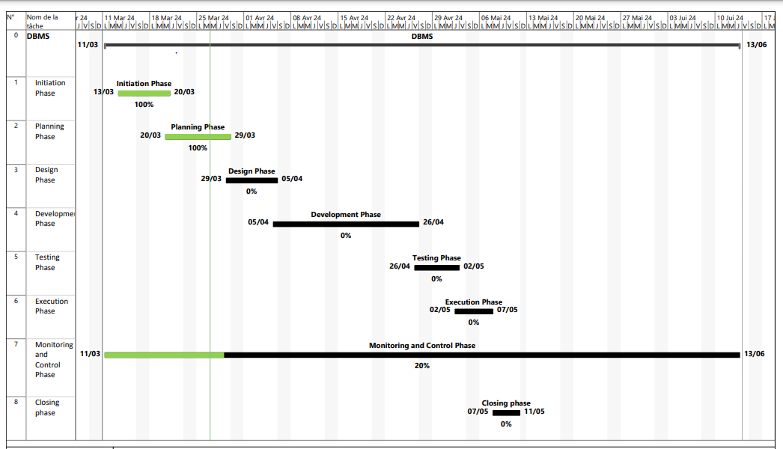

**Figure 1: Gantt Chart showing the progress of the project**

## **Risk Management:**

- Identify potential risks such as scope creep, resource constraints, and technology challenges.

- Develop mitigation strategies to address identified risks and minimize their impact on project deliverables.

- Regularly assess and update the risk register throughout the project lifecycle.

## **Communication Plan:**

- Hold regular project meetings to discuss progress, issues, and action items.

- Maintain open communication channels with stakeholders through WhatsApp, email updates, progress reports, and feedback sessions.

- Establish a central repository for project documentation and communication.

## **Quality Assurance:**

- Adhere to industry best practices and standards for database design, development, and deployment.

- Conduct thorough testing at each stage of the project to ensure system reliability, performance, and security.

- Seek input and validation from stakeholders to verify that the system meets their needs and expectations.